Follow the directions below for the density web quest- complete sentences- ink
1. What is mass?
______________________________________________________________________________________________________________________________________
2. What is volume?
______________________________________________________________________________________________________________________________________
3. How is mass different than weight?
______________________________________________________________________________________________________________________________________
4. What tool do you use to measure mass? What do you label mass?
______________________________________________________________________________________________________________________________________
5. What tools can you use to measure volume (you may need to use more than one slide)? What do you label volume (2 ways)?
______________________________________________________________________________________________________________________________________
6. Define density without using the words mass or volume in the definition.
_________________________________________________________________________________________________________________________________________________________________________________________________________
7. What are the three ways to calculate density?
______________________________________________________________________________________________________________________________________
8. How can knowing the density of an object help us identify what the object is made of?
______________________________________________________________________________________________________________________________________
9. What is the density of water?
___________________________________________________________________
10. How does knowing the density of water help us in the science class?
_________________________________________________________________________________________________________________________________________________________________________________________________________
11. Why would a cherry put in a glass of liquid rise to the surface of the glass? (use previous knowledge to make a hypothesis)
______________________________________________________________________________________________________________________________________
12. What conclusion can you make about the cherry and its density mentioned in question #11?
_________________________________________________________________________________________________________________________________________________________________________________________________________
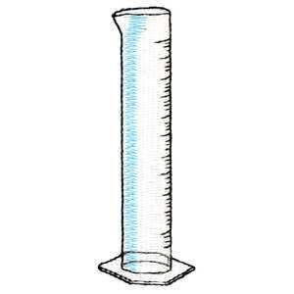
13. Assuming the following items don’t mix, stack them in the graduated cylinder below by writing them next the cylinder in order by the way they would line up.
a water 1g/mL
b. ice .92g/mL
c. corn syrup 1.38 g/mL
d. corn oil .93 g/mL
e. steel 7.81g/mL
f. wood .85 g/mL
g. rubber 1.34 g/mL

14. Describes what happens to a matters density as its volume changes or its mass changes? Does its density change? Why or why not? Do you have proof?
_________________________________________________________________________________________________________________________________________________________________________________________________________
15. What takes up more space, a pound of feathers or a pound of lead? (think about it)
______________________________________________________________________________________________________________________________________
16. Which has more mass…the feather or the lead? (think about it)
_________________________________________________________________________________________________________________________________________________________________________________________________________
17. Name at least two things you use in your everyday life that density plays an import piece of their life. Be sure to tell why it is important.
____________________________________________________________________________________________________________________________________________________________________________________________________________________________________________________

18. If an object has more molecules it is said to be
___________________________________________________________________________________________________________________________

And one has less it is said to be
__________________________________________________________________________________________________________________________

19. What is your weight on Jupiter? What is your weight on Earth? Why are they different? (in pounds)
________________________________________________________________
20. The remaining time can be spent on science page sites.

